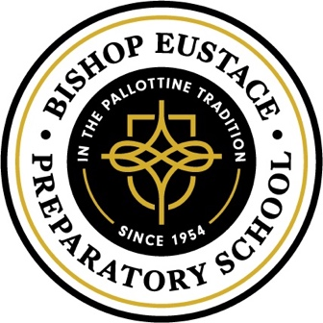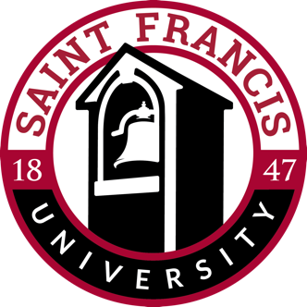

Bishop Eustace Preparatory Partners with Saint Francis University

In an effort to perpetuate and champion values and tradition of the Catholic education, and to provide exceptional developmental opportunities for college bound students, Bishop Eustace Preparatory School and Saint Francis University are excited to have partnered together to offer the Partnership for Excellence in the Advancement of Catholic Education (PEACE) for our students.

Highlights include:
- Guaranteed admissions and a four year renewable scholarship to graduates of Eustace Prep who enroll at Saint Francis University in qualified academic programs.
- Weighted consideration for students pursuing admission to specialized accelerated academic programs (4+1 MBA, Nursing BSN, 4+1 Occupational Therapy, 4+3 or 3:3 Physical Therapy, 3+2 Physician Assistant Sciences)
- Complimentary overnight stay and meals for students and families interested in visiting.
- Preferred status to Eustace Prep students to participate in the Study Abroad Program. The Study Abroad program offers a select number of high school students the opportunity to pursue a 3-credit, college-level course that culminates in a 10-day experience at Saint Francis’ study abroad facilities in Ambialet, France.
- A discount for students interested in enrolling in one STEAM Summer Academy hosted by the SFU Science Outreach Center. Successful completion of a STEAM Academy also qualifies students for an additional scholarship to Saint Francis University should they enroll as an undergraduate student.

We are very excited to work with Saint Francis University! We encourage students to contact their college counselor for more information.

